Intro

From market momentum to wildlife returning on the ground, March highlights nature market acceleration.

Hero Feature: Demand | Approved: CS and Wren

One Deal. One Partner: A Smarter Route to BNG Compliance

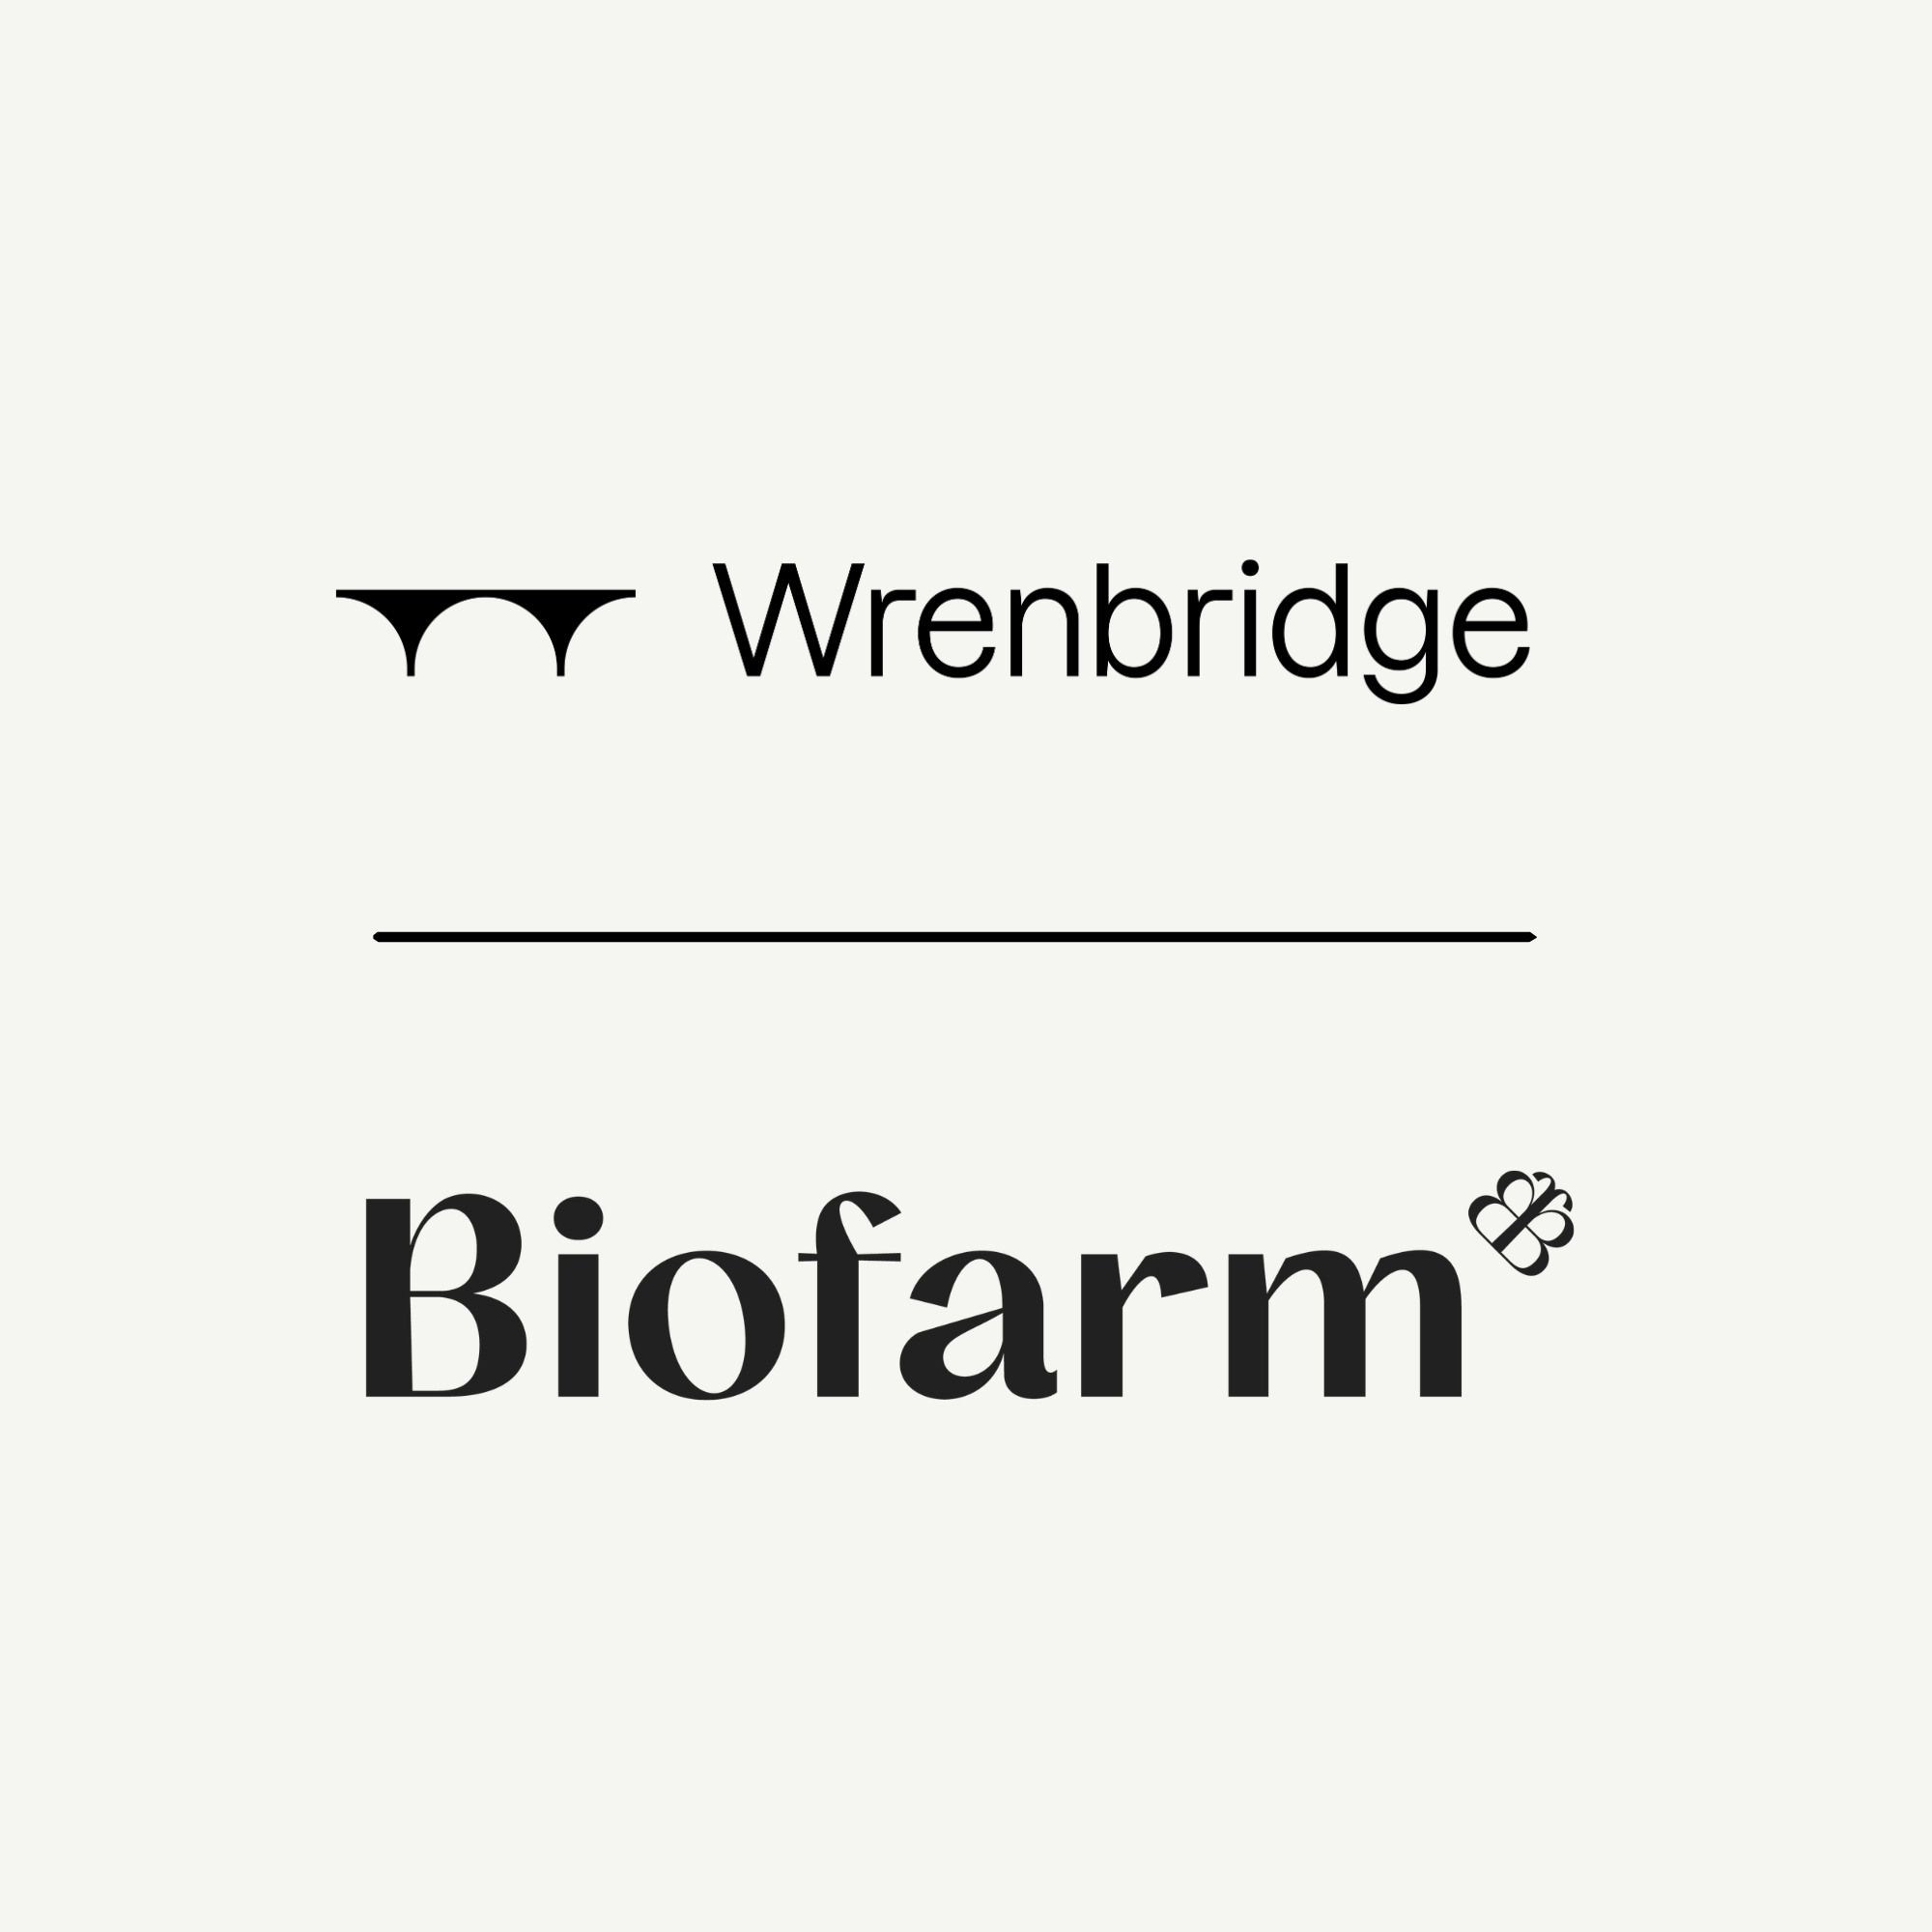

For many developers, delivering BNG isn’t just about securing units, it’s about navigating complexity. Different habitat types. Multiple providers. Tight timelines.

We think there’s a better way to do it.

Instead of expecting developers to piece together units from different habitat banks and negotiate multiple agreements, we design one joined-up solution. We look at the biodiversity requirement in the round, source the right habitats, from our own sites or trusted partners, and structure it as one straightforward deal.

That’s exactly what we did for UK leading property developer, Wrenbridge.

The scheme had a biodiversity deficit across medium and high distinctiveness habitats and needed a fast, cost-effective route to compliance.

Rather than sending them to multiple providers, we assessed the requirement and built a bespoke solution that:

Traded up from individual trees and medium distinctiveness woodland to lowland meadow habitat, delivering the required biodiversity uplift more cost-effectively

Aggregated additional habitat units, including lowland mixed deciduous woodland, sourced through our partner network

Structured everything as one transaction, removing the need for multiple negotiations and contracts

The result was a simple, cost-effective BNG solution that reduced time, complexity and cost for the developer, enabling them to meet their biodiversity requirements without delay.

Every development has a different biodiversity challenge. Our job is to make it work.

If you’re facing a complex BNG requirement - multiple habitats, tight timelines, or fragmented supply - get in touch. We’ll help you turn it into one clear, workable solution.

[CTA] For friction free BNG, contact us

Secondary Feature: Supply | Approved: CS  Pending: Badger Bank

New habitat bank launching soon: Badger Bank Farm, North Yorkshire

AWAITING IMAGE

Developers delivering projects across North Yorkshire will soon have access to a significant new supply of BNG units.

Biofarm is preparing to launch Badger Bank Farm, a 30-hectare habitat site in North Yorkshire delivering 232 BNG units across a diverse mix of habitats, including other neutral grassland, mixed scrub, individual trees, species-rich hedgerow and watercourses.

Serving developments across North Yorkshire, Leeds, Wakefield, Doncaster, Rotherham and surrounding authorities, the site offers a locally relevant, policy-aligned solution for meeting BNG requirements.

Positioned within the Southern Magnesian Limestone National Character Area, Badger Bank sits adjacent to ancient woodland and the River Ure corridor, creating a strong opportunity to enhance habitat connectivity and support regional priorities for grassland restoration and woodland buffering.

Through a nature-led approach, former arable land will be restored into species-rich neutral grassland and diverse scrub habitats, supported by parkland trees and enhanced hedgerows. The result will be a resilient habitat mosaic that strengthens ecological networks, supports farmland birds and bats, wetland birds from the nearby Site of Special Scientific Interest, and improves water quality across the wider landscape.

With a strong local catchment and a varied unit mix, Badger Bank Farm offers an attractive new BNG solution for developers operating across the region.

Get in touch to discuss availability and how, through Badger Bank Farm, we can support your upcoming planning applications.

[CTA] Buy Badger Bank BNG

Feature: Market Leadership | Approved: CRS, LN
From strategy to soil: why site visits matter for BNG

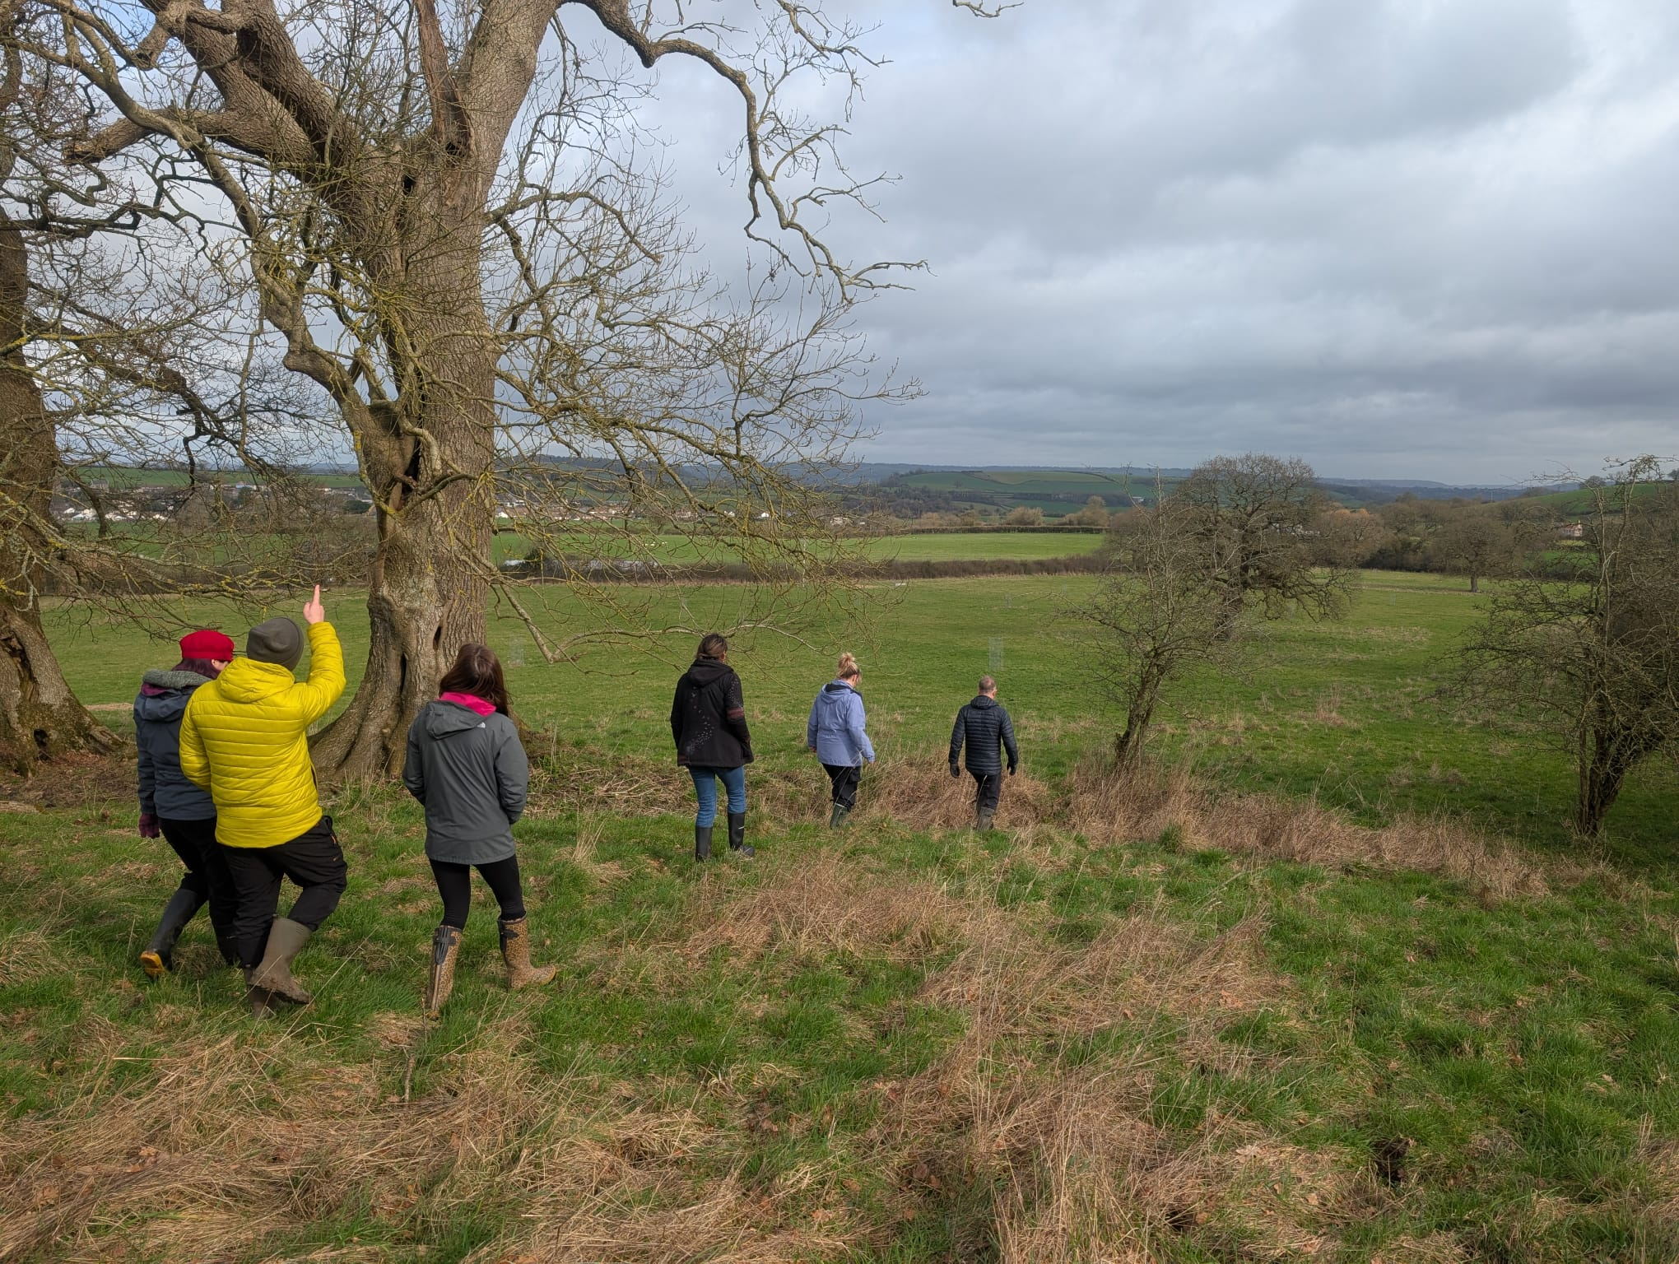

We recently welcomed the Nature Recovery team from the West of England Mayoral Combined Authority to Sleight Farm (BGS-281124001) in Somerset.

WEMCA plays an important role in shaping the region’s Local Nature Recovery Strategy, helping ensure that growth, development and nature recovery move forward together across the West of England.

Bringing strategy out of documents and into real landscapes was exactly the purpose of the visit, because when it comes to BNG, the most useful conversations rarely happen in meeting rooms.

They happen in fields, along hedgerows and beside new habitats - where policy meets the practical realities of land management and development delivery.

Seeing BNG in practice
At Sleight Farm, we walked the site together and explored how habitat banks work on the ground. The discussion ranged from habitat creation techniques and long-term monitoring to the role of nature tech, ecosystem service metrics and the emerging role of green finance in supporting nature recovery.

Just as important were the honest conversations about the complexities developers face delivering BNG, and how habitat banks can help manage ecological and financial risk while supporting wider landscape recovery.

For regional authorities developing Local Nature Recovery Strategies, these practical insights matter. Strategies are most effective when they reflect what works in the field, not just what looks good on paper.

Why visits like this matter
Site visits create a shared understanding between policymakers, planners, developers and landowners.

They allow people to:
- See how BNG habitat creation is delivered and managed over the long term
- Understand how habitat banks fit within the wider BNG market
- Explore how projects can align with regional nature recovery priorities
- Build relationships that support collaboration at landscape scale

Ultimately, they help connect policy, finance and land management in ways that accelerate nature recovery.

An open invitation
We believe transparency and collaboration are essential if BNG is going to deliver for nature, landowners and development alike.

That’s why we regularly welcome partners and stakeholders to our habitat banks to see the work for themselves.

If you’re a developer looking to understand how our habitat banks support BNG delivery, or a landowner exploring opportunities in nature markets, we’d be glad to show you around.

There’s no substitute for seeing it on the ground.

[CTA] Arrange a site visit

Feature: Ecology | Approved: SN

Early Signs of Ecological Recovery

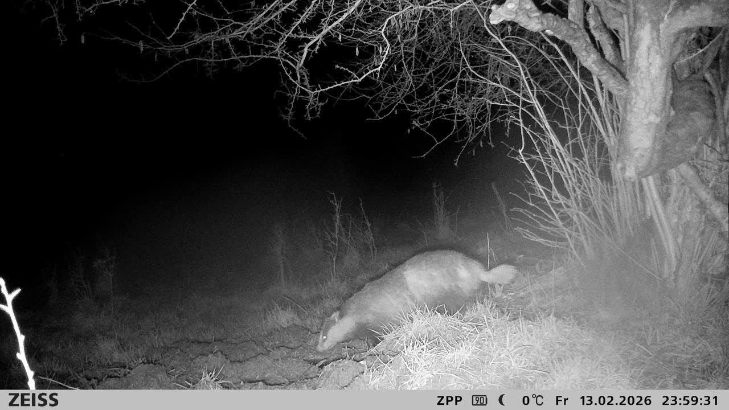

Our trail cameras are beginning to show how wildlife is responding to habitat restoration across our sites.

Badgers have been recorded foraging at night, while a field mouse was spotted moving through the undergrowth. Roe deer are now regularly passing through areas of regenerating habitat, making use of the developing mosaic of grassland and scrub.

A particularly encouraging sighting was a polecat. Once widespread across England, polecats declined sharply due to persecution and habitat loss and only recently began recolonising parts of the country. Their presence is often associated with improving habitat quality and healthy prey populations.

Encouragingly, rabbits are also beginning to reappear across the restored grassland and scrub areas. As an important prey species, they help support predators such as polecats, foxes and birds of prey, strengthening the wider ecological food web.

Along the stream corridor, a firecrest has been observed at the woodland edge, while a red fox was captured pausing for a drink. A buzzard was also filmed wading along the shallow riverbed. A rare glimpse of how wildlife is beginning to use these recovering habitats.
What stands out most is the speed at which wildlife is responding. As pressures are reduced and habitats begin to reestablish, species are naturally returning and starting to use the landscape in different ways.
These early observations are a small but encouraging indication that the ecological restoration underway is beginning to support a more diverse and functional ecosystem.
[CTA} Learn more about the environmental impact of our BNG bank
Feature: Ecology | Approved: SN

Sleight Farm: Winter Work, Spring Renewal

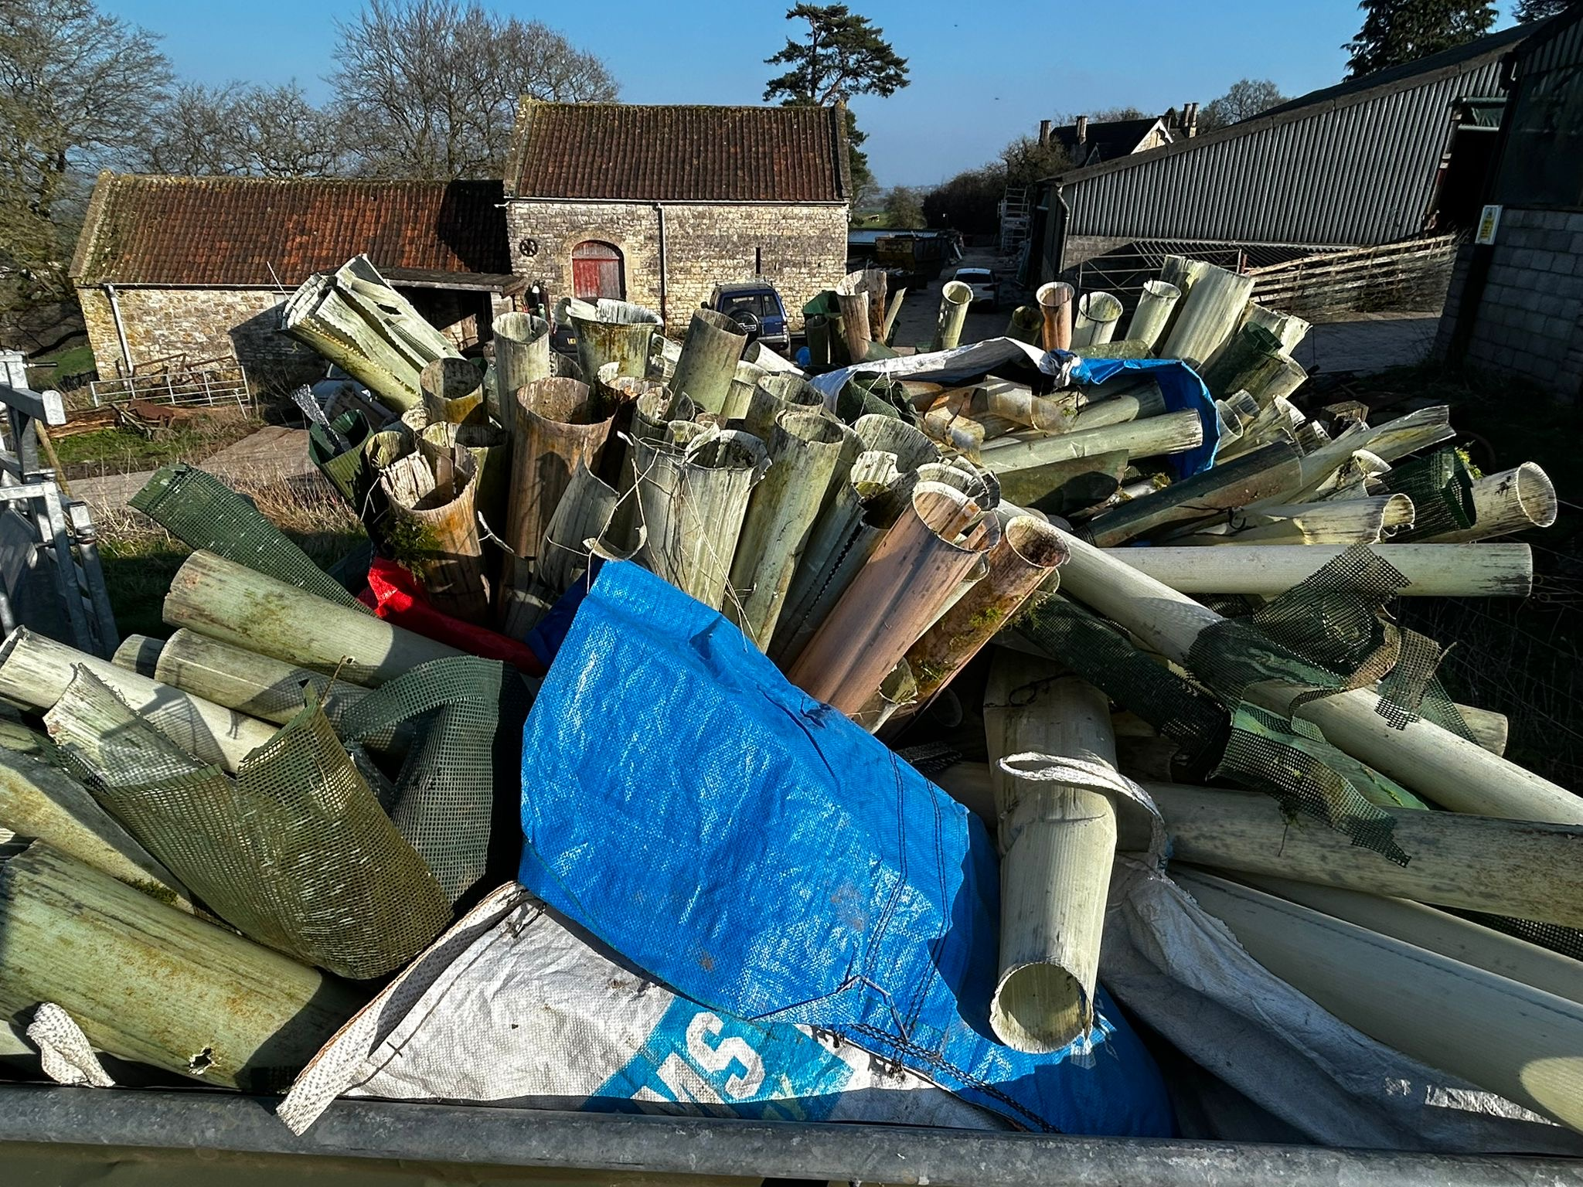

Despite relentless winter rain, practical conservation work has continued across the farm. Late winter is one of the most important windows for restoration: the ground is workable, wildlife disturbance is minimal, and the foundations for spring growth can be put firmly in place.

Planning for the future
This winter the team planted 55 new field trees, including oak, beech and hornbeam, as part of our long-term treescape restoration programme. This brings the total number of new trees planted to 120, with another 60 planned for winter 2026.

Over time these trees will reconnect fragmented woodland areas and provide vital habitat for wildlife. Oaks in particular are ecological powerhouses in the British landscape, supporting thousands of species from birds and mammals to insects and fungi.

To protect our young trees, we are using reusable steel cactus guards, designed with outward spikes that discourage animals from pushing or rubbing against the trunks while allowing the trees to grow naturally, without plastic waste.

Clearing the Past
Alongside planting new trees, we’ve been removing the remnants of older interventions. Over the last two winters we have removed hundreds of metres of old barbed wire fencing, derelict mesh and more than 500 redundant plastic tree guards.

Old fencing fragments the landscape and can pose serious hazards to wildlife, particularly when rusting barbed wire becomes hidden in vegetation. Meanwhile, aging plastic tree guards often break down into brittle fragments leaving plastic waste and restrict the growth of the trees they were meant to protect.

Removing them restores safer wildlife movement and helps the farm function as one connected landscape again.

Restoring the Grasslands
One of our central goals is to restore species-rich grassland in areas long dominated by coarse grasses. Historically, intensive sheep grazing created tightly cropped turf that favours grasses but leaves little room for wildflowers to establish. To reverse this, we are using a mix of grazing animals that each reshape the land in different ways.

Tamworth pigs, English Longhorn cattle and Exmoor ponies are now working the lowland fields. Pigs root through dense vegetation and compacted soil, exposing patches of bare ground where long-buried seeds can germinate. Meanwhile, cattle and ponies graze less intensively than sheep, their heavier weight and “rip-and-tear” grazing help break up the dense grass layer and creates openings for new plants.

Together these natural processes begin to create a more varied sward, opening space for wildflowers and increasing plant diversity, bringing more pollinators, insects and wildlife back into our fields.

If weather conditions allow, livestock will move to higher ground by mid-May. The lowland meadows will then grow through the summer before being cut for hay later in the season.

The Landscape Awakens
With longer days and rising temperatures, the farm is beginning to stir again. In the woods, primrose, bluebell and wild garlic are emerging across the forest floor, while birds are establishing territories and preparing nesting sites. European hares are also becoming more visible after the quieter winter months.

After a season of hard groundwork, the landscape is ready to respond, and spring is beginning to show the results.

